**Think Bridge: (Shop Bridge Form)**

* This form is developed by using **ASP.NET MVC** and **PGSQL** database.
* Create table query is in .txt file
* To perform Save edit and update used inline queries using **ADO.NET**

1. View Page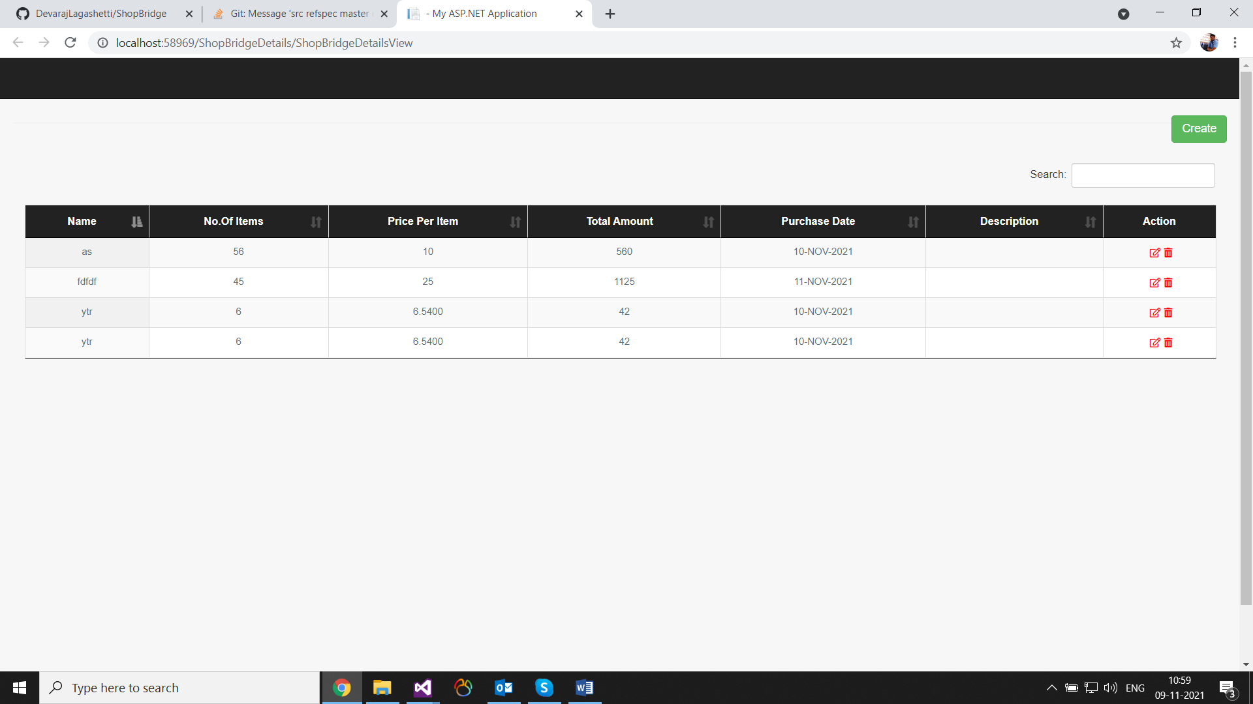-> This screenshot is View page which shows saved data and CREATE button to create new shop bridge.
2. Create Page

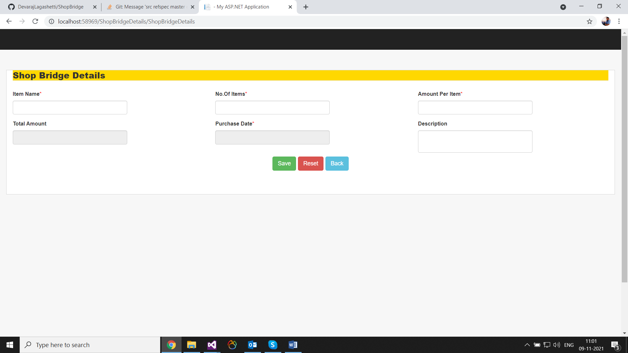This screenshot shows fields related to the Form